**Daily Scrum or Standup Meeting**

Team name: Team 08

Scrum Master: Tristan Thomas

Date: Nov 4

|  |  |  |  |
| --- | --- | --- | --- |
| **Team Member** | **What did you do since the last Scrum?** | **What do you plan to do before the next scrum?** | **What obstacles do you have?** |
| Hannah Howell | * reviewed and approved others’ code * made create_auction in line with the rest of the project’s UI design | * link everything correctly in /home * add ability for user to add local auction code |  |
| Garrett Johnson | * Learned more about Django’s unit testing | * Add unit tests to auction creation page * Add button to publish auction * Start on next task (Live item) | * Need to learn more about unit testing |
| Zion Steiner | * Finished auction_detail view   + Auction items are now included in view   + Expandable add item form is rendered for the admin | * Add view and template for my_bids | * Bid model and ability to place bids needs to be implemented before I can start |
| Tristan Thomas | * Added Item view * Tested website on mobile | * Add feature for admin to edit items in item view * Start next task | * Read more Vuetify documentation |
| N/A |  |  |  |

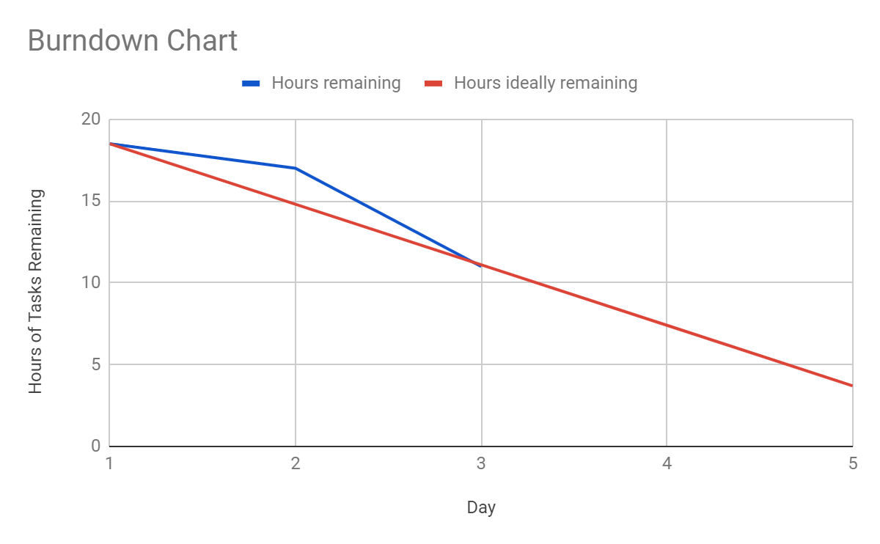

# Screenshot of your project board

